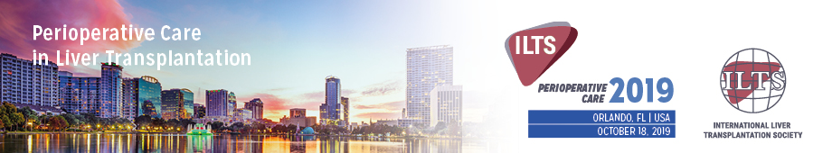

ILTS Perioperative Care in Liver transplantation
AdventsHealth
Nicholson Center
404 Celebration Pl, Celebration, FL 34747, Orlando
October 18, 2019

EDUCATIONAL CASE SUBMISSION

Presenter:
Name:

Affiliation:

E-mail Address:

Case submission:
Title
Enter your title here

Learning Objectives (50 words)
Enter your learning objectives here

Brief Description (300 words)
Enter your description here

